IT5010: Assignment #1

Practical Project – Case Study

Report

|  |  |
| --- | --- |
| **Student Name:** | *Ben Rush* |
| **Student ID:** | *20230984* |
| **Due Date:** | *1/4/23* |

1

**Contents**

1. Executive Summary 2

2. Network Diagram 3

3. Quotation 3

4. (D) Communication Channel Security 4

5. (E). Support Call Prioritisation 5

7. References 5

# Executive Summary

(Explain the scenario and summarise your work in a short paragraph.)

I am creating a new IT support site in Auckland. It requires a secure network between multiple devices. I will be using a firewall as my first point of security. I will be using this to monitor incoming and outgoing network traffic to establish a safe network. My next layer is a vpn. This will be used to create a secure channel between devises to ensure the data can not be accessed by sources that don’t have the encryption key. Once my security has been created, I will have a server that connects my devices to the network. I will also be using a Norton antivirus. I have also bought a software that is used to monitor and manage call logs and customer support that is based on the rules from high to low priority incidents.

# Network Diagram

(Enter a network Diagram here and give an explanation. You can use [www.draw.io](http://www.draw.io) to draw the network

diagram online. Make sure all components are labelled.)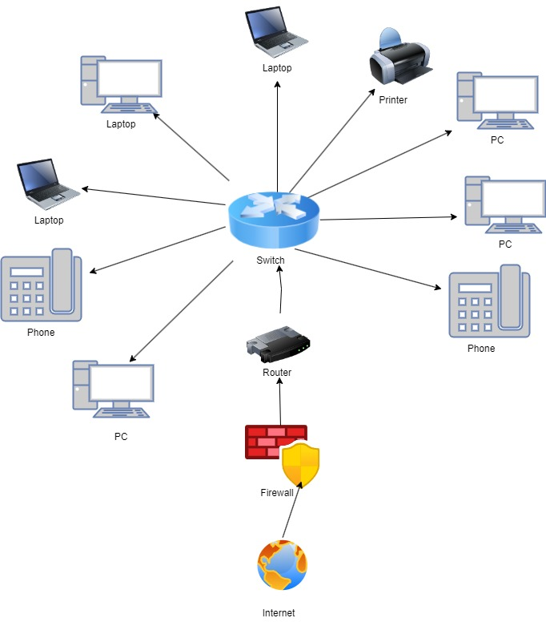

# Quotation

(Fill in the table to answer Tasks A, C and E)

|  |  |  |  |
| --- | --- | --- | --- |
| **Items** | **Cost** | **C. Rationale and Justification for each component**  *(Provide brief justification about why you chose this specific item.)* | **Reference**  APA (7th ed.) format. E.g., (Rasmussen, 2021, para. 2) |
| **A.** Hardware/Software Components | $5948  $1954  $186 | 4x pc (includes monitor keyboard and mouse)  2x laptop  2x phone  I choose these devises for my business because they are necessities for a business to run. | [PCs Source](https://www.pbtech.co.nz/product/WKSLEN5190379/Lenovo-ThinkCentre-M75Q-G2-Tiny-Business-PC-AMD-Ry)  31/3/23  [Laptop Source](https://www.pbtech.co.nz/product/NBKLEN150200/Lenovo-V15-G2-Business-Laptop-156-FHD-Intel-i5-113)  31/3/23  [Network desk phone Source](https://www.pbtech.co.nz/product/IPHGSM1044/Grandstream-GRP2602P-SIP-Deskphone---PoE-2-Line-Es) 31/3/23 |
| Network devices | $963  $201 | 1x router  I choose a router so It could send the network to the switch this router includes a firewall.  1x switch  I choose to use a switch so I could have all devices connecting back to one source. | [Firewall Router Source](https://www.pbtech.co.nz/product/NETDTK29273/DrayTek-Vigor2927AX-Dual-GigE-WAN-RouterFirewall-I)  31/3/23  [Switch source](https://www.pbtech.co.nz/product/SWHEDM1044/Edimax-GS-1016-V2-16-Port-101001000-Gigabit-Rack-m)31/3/23 |
| **B.** Computing equipment and network components | $60.4  $594 | 10x IPV 4 network cables  I am using these cables to connect the devices to the network via the server.  2x docking station.  I decided to use this item to connect the laptops to the server and so updates can run while the laptop is closed. | [Ethernet cable](https://www.pbtech.co.nz/product/CABCXT820300/Cruxtec-3m-Cat6-Ethernet-Cable---Black-Color) 31/3/23  [Docing station](https://www.pbtech.co.nz/product/NBDLEN400090/Lenovo-ThinkPad-USB-C-Dock-ThinkPad-Universal-USB) 31/3/23 |
| Servers (if applicable) |  |  |  |
| Infrastructure |  |  |  |
| Printers | $102 | 1x printer | [Printer Source](https://www.pbtech.co.nz/product/PTRBRT01050/Brother-Home-DCPJ1050DW-Inkjet-MFP-Printer-PrintCo) 31/3/23 |
| Related hardware  Included with pcs | $0 | Monitors  Keyboards  mouse |  |
| Software | $77 per year  for 10 devices  $250  For 10 devises per year  $175  For 10 users per year | Mcafee vpn  I choose this vpn because it is designed for small businesses and it offers 10 vpn secured channels which is how many devises I have.  Norton security antivirus  I will be using this to protect my network from malware adware and virus’s.  3CX is a tool used to monitor and manage call logs and customer support. | [Mcafee Vpn Source](https://www.mcafee.com/consumer/en-nz/landing-page/direct/sem/search-campaign.html?csrc=google&csrcl2=nonbrand&cctype=%5bEN-NZ%5d%5bSearch%5d%5bNB%5d%20Freemium&ccstype=%5bnb%5d%5bbmm%5d%20free%20vpn&ccoe=direct&ccoel2=sem&pkg_id=&affid=1484&cid=en-nz&utm_source=Google&utm_medium=SEM&utm_campaign=%5bEN-NZ%5d%5bSearch%5d%5bNB%5d%20Freemium&utm_content=%5bnb%5d%5bbmm%5d%20free%20vpn&utm_term=free%20vpn%20download&gad=1&gclid=CjwKCAjw5pShBhB_EiwAvmnNV6va7ntotZy4fyWSBOP5InEh4evW5aZSNHvIOCXvvHKaHrF_6YUKGBoCoukQAvD_BwE)  31/3/23  [Norton antivirrus Source](https://buy-static.norton.com/norton/ps/ad/pages/nz/4up_nav_ns1_ns_nsbu_nz_en_pla_notw_branded_n360.html?om_sem_cid=hho_sem_sy:nz:pla:en:n:pl:kw0000434795:392777356260:c:google:6955979491:80641379905:aud-329160963824:pla-371063648047&nortoncountry=NZ&&&gclid=CjwKCAjw5pShBhB_EiwAvmnNV4tFLFaqaQNJpMNpCK4jNgrMvS92rAl8ZtCxmbQeuJx5_GduiG9HNxoC-7oQAvD_BwE&gclsrc=aw.ds)  31/3/23  [3CX Source](https://www.3cx.com/ordering/pricing/)  31/3/23 |
| Accessories |  |  |  |
| Security protocols | 0$  Included in router. | 1x firewall  My Router includes a firewall. |  |

# (D) Communication Channel Security

(Explain how you will secure the communication channel between the two sites.)

I will be using a Vpn to create a private and secure channel between my devises. It will ensure that no one without an encryption key can view my data, protecting it from external sources. I Will also be using a firewall to filter incoming and outgoing traffic and create a safe network. I will also be installing an antivirus to protect my business about to get rid of adware, malware and virus’s.

# (E). Support Call Prioritisation

(Explain how you will prioritise the calls. You can list the rules that you have defined and practiced using Spiceworks.)

I will be using the software 3CX to manage the call logs and IT support. It will classify the priority via the rules below.

|  |  |  |  |
| --- | --- | --- | --- |
| **Rule** | **Problem** | **Effect on Business** | **Priority** |
| CEO cannot access their Primary Programs. | They cannot run the business without these programs. | This will have a big impact on the business because it cannot function or profit without the CEO. | High |
| Switch isn’t responding. | All the devices cannot connect to the network. | This impacts the business ability to run because all the devices can’t be used leaving all workers unable to do their jobs. | High |
| The program used to record shifts and track pay is down. | Consumers cannot document their hours and access their pay slips. | Since pay is vital to the business running but it only is processed once a fortnight this job needs to be completed but the business can still function. | Medium |
| One of the 2 business Phones has broken due to water damage it needs to be replaced with a new one. | New Business phone is required because the old one was damaged beyond repair. | This problem directly will not have a huge impact on the business however if the other phone is broken, they will have no source of communication making the business hard to operate. | Medium |
| Monitor screen is flickering | Occasional flicker at the top of the screen. Hardware needs to be replaced. | This will not have a big impact on the business because the monitor is still functional, and the customer can still work until its replaced. | Low |
| Printer isn’t working. | Printer cannot connect to the devices so customers cant print. | This Impacts customers’ ability to print which will not affect the business ability to function or profit. | Low |

1. **Summary**

(Reflect on your learning and the challenges of designing a network solution)

This assessment challenged me in good ways and helped me use my old knowledge along with a lot of new things to design this network solution. I had some challenges creating the call support prioritization table my mind when blank and I didn’t understand how to format it. After researching different ones and checking out a few examples I combined my knowledge of the different situations I would face at my old job, and I prioritized them using the (impact on business= Important of componence + Severity of event) Using this formula helped me understand the task and put it into my own words.

I learnt a lot about the different security measures that are necessary for a safe network.

# References

(APA (7th) format can be found in Canvas on the ‘Referencing Format’

e.g., Rasmussen, C. (2021, October 12). Icy ‘glue’ may control pace of Antarctic ice-shelf breakup. National

Aeronautics and Space Administration.

<https://www.nasa.gov/feature/jpl/icy-glue-may-control-pace-of-antarctic-ice-shelf-breakup>)

I used pb tech to find the prices for all the equipment I needed for the set-up. (2023 April 4th)

<https://www.pbtech.co.nz/>

# Norton security package (2023 April 2nd)

[Norton antivirrus Source](https://buy-static.norton.com/norton/ps/ad/pages/nz/4up_nav_ns1_ns_nsbu_nz_en_pla_notw_branded_n360.html?om_sem_cid=hho_sem_sy:nz:pla:en:n:pl:kw0000434795:392777356260:c:google:6955979491:80641379905:aud-329160963824:pla-371063648047&nortoncountry=NZ&&&gclid=CjwKCAjw5pShBhB_EiwAvmnNV4tFLFaqaQNJpMNpCK4jNgrMvS92rAl8ZtCxmbQeuJx5_GduiG9HNxoC-7oQAvD_BwE&gclsrc=aw.ds)

# Call center management software (2023 April 2nd)

[3CX Source](https://www.3cx.com/ordering/pricing/)

# Vpn secure network (2023 April 2nd)

[Mcafee Vpn Source](https://www.mcafee.com/consumer/en-nz/landing-page/direct/sem/search-campaign.html?csrc=google&csrcl2=nonbrand&cctype=%5bEN-NZ%5d%5bSearch%5d%5bNB%5d%20Freemium&ccstype=%5bnb%5d%5bbmm%5d%20free%20vpn&ccoe=direct&ccoel2=sem&pkg_id=&affid=1484&cid=en-nz&utm_source=Google&utm_medium=SEM&utm_campaign=%5bEN-NZ%5d%5bSearch%5d%5bNB%5d%20Freemium&utm_content=%5bnb%5d%5bbmm%5d%20free%20vpn&utm_term=free%20vpn%20download&gad=1&gclid=CjwKCAjw5pShBhB_EiwAvmnNV6va7ntotZy4fyWSBOP5InEh4evW5aZSNHvIOCXvvHKaHrF_6YUKGBoCoukQAvD_BwE)